**ASSIGNMENT – I**

NAME: CHINNARAJ.K

REGISTER NUMBER: 422319205003

COLLEGE: THIRUVALLUVAR COLLEGE OF ENGINEERING AND

TECHNOLOGY

TEAM ID: PNT2022TMID39130

**QUESTION:** Make a smart home in Tinker kart, using 2+ sensors,led,buzzer in sing code and circuite.

**CODE:**

// C++ code

//

void setup()

{

pinMode(12, OUTPUT); pinMode(2,OUTPUT);

}

void loop()

{

int m=digitalRead(8); double a=analogRead(A1); double v=a/1024;

double tvolt=v*5; double o=tvolt-0.5; double t=o*100; if(t>50)

{

digitalWrite(2, HIGH);

}

else

{

digitalWrite(2, LOW);

}

if(m==1)

{

digitalWrite(12, HIGH);

}

else

{

digitalWrite(12, LOW);

}

}

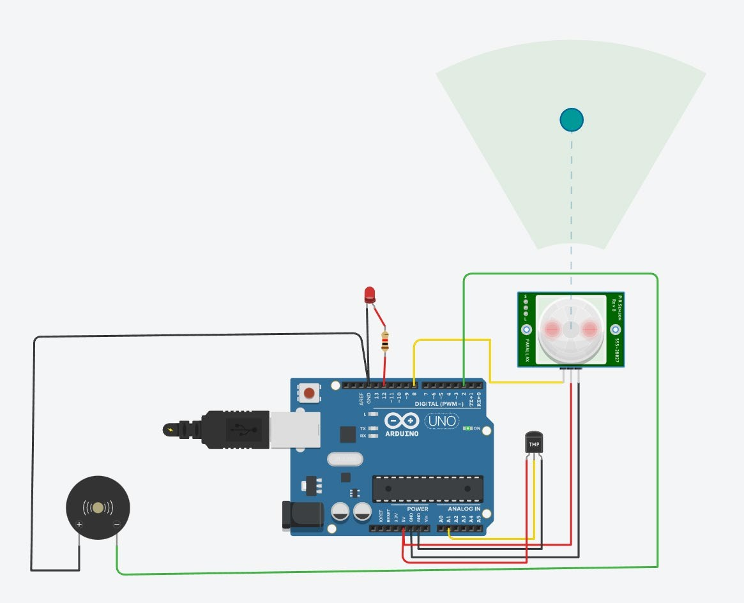OUTPUT: